
DEPARTMENT OF COMPUTER SCIENCE AND ENGINEERING

CS23432 – Software Construction

(REGULATION 2023)

RAJALAKSHMI ENGINEERING COLLEGE,
Thandalam, Chennai-602015

Name: THIRUKUMARAN
Register No: 240701568 Year / Branch : II / CSE Semester: 4
Academic Year: 2026

INDEX

S.No. | Date | Title
1. |  | Azure Devops Environment Setup.
2. |  | Azure Devops Project Setup and User Story Management.
3. |  | Setting Up Epics, Features, And User Stories for Project Planning.
4. |  | Sprint Planning.
5. |  | Poker Estimation.
6. |  | Designing Class and Sequence Diagrams for Project Architecture.
7. |  | Designing Architectural and ER Diagrams for Project Structure.
8. |  | Testing – Test Plans and Test Cases.
9. |  | Load Testing and Pipelines.
10. |  | GitHub: Project Structure & Naming Conventions.


EXP NO: 1
AZURE DEVOPS ENVIRONMENT SETUP

Aim:
Create Epic, Features, User Stories, Task
To set up and access the Azure DevOps environment by creating an organization through the Azure portal.

INSTALLATION
- Open your web browser and go to the Azure website: https://azure.microsoft.com/en-us/get-started/azure-portal.
Sign in using your Microsoft account credentials.
If you don't have a Microsoft account, you can create one here: https://signup.live.com/?lic=1

- Azure home page
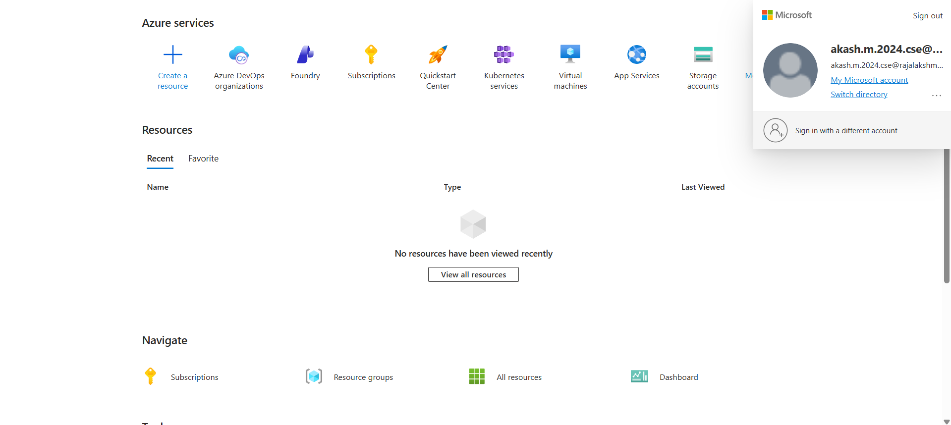

- Open DevOps environment in the Azure platform by typing Azure DevOps Organizations in the search bar.
- Click on the My Azure DevOps Organization link and create an organization and you should be taken to the Azure DevOps Organization Home page.
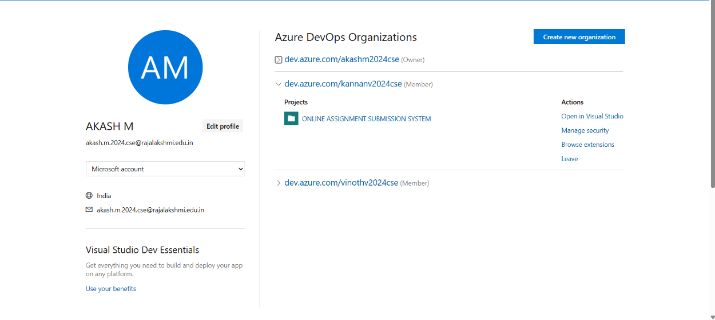

Result:
Successfully accessed the Azure DevOps environment and created a new organization through the Azure portal.

EXP NO: 2
AZURE DEVOPS PROJECT SETUP AND USER STORY
MANAGEMENT

Aim:
Create Epic, Features, User Stories, Task
To set up an Azure DevOps project for efficient collaboration and agile work management.

- Create An Azure Account

- Create the First Project in Your Organization
  - After the organization is set up, you’ll need to create your first project. This is where you'll begin to manage code, pipelines, work items, and more.
  - On the organization’s Home page, click on the New Project button.
  - Enter the project name, description, and visibility options:
Name: Choose a name for the project (e.g., LMS).
Description: Optionally, add a description to provide more context about the project. Visibility: Choose whether you want the project to be Private (accessible only to those invited) or Public (accessible to anyone).
  - Once you’ve filled out the details, click Create to set up your first project.

- Once logged in, ensure you are in the correct organization. If you're part of multiple organizations, you can switch between them from the top left corner (next to your user profile). Click on the Organization name, and you should be taken to the Azure DevOps Organization Home page.
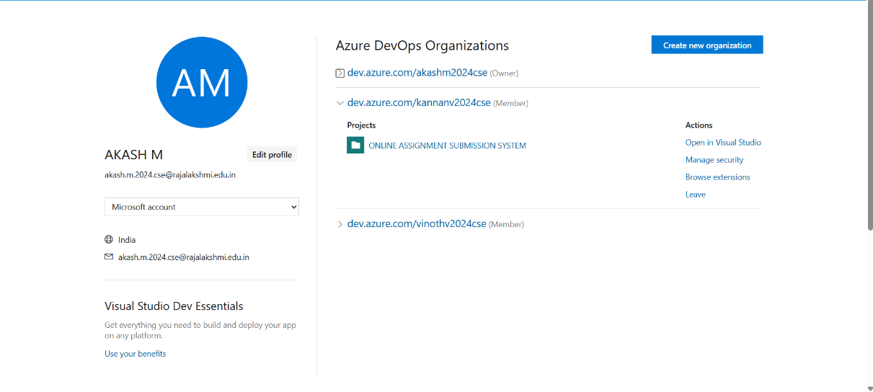
- Project dashboard

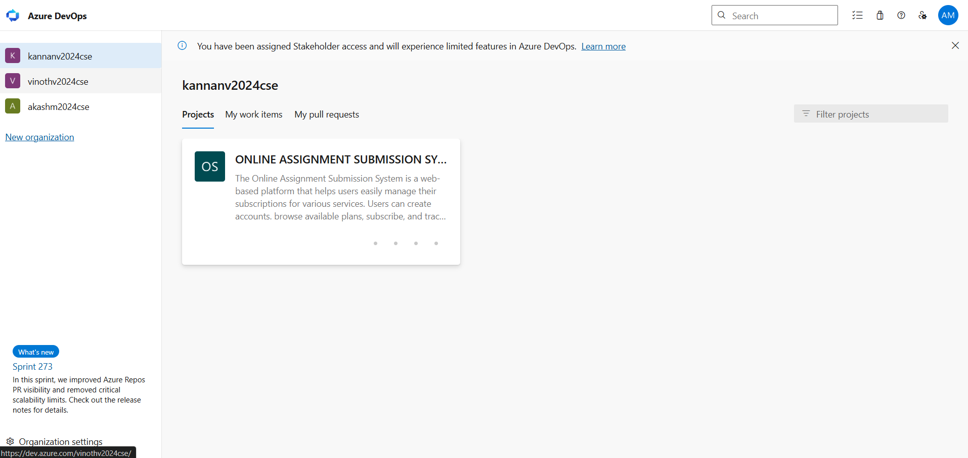

- To manage user stories:
  - From the left-hand navigation menu, click on Boards. This will take you to the main Boards
page, where you can manage work items, backlogs, and sprints.
  - On the work items page, you'll see the option to Add a work item at the top. Alternatively, you can find a + button or Add New Work Item depending on the view you're in. From the Add a work item dropdown, select User Story. This will open a form to enter details for the new User Story.
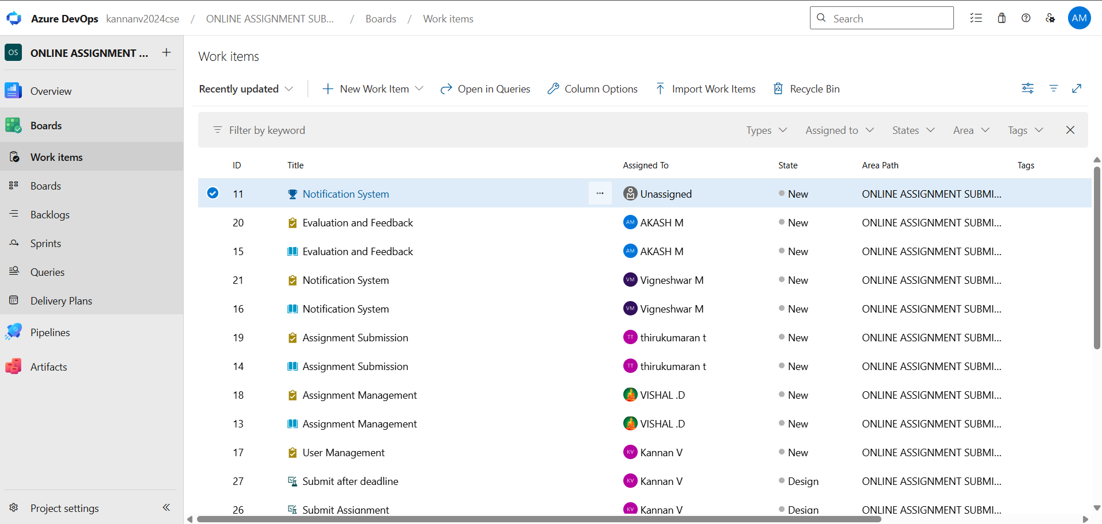

Result:

setup.

Successfully created an Azure DevOps project with user story management and agile workflow

SETTING UP EPICS, FEATURES, AND USER STORIES FOR PROJECT PLANNING

Aim:
EXP NO: 3
e Epic, Features, User Stories, Task
To learn about how to create epics, user story, features, backlogs for Online subscription management System project.

Create Epic, Features, User Stories, Task


Fill in Epics
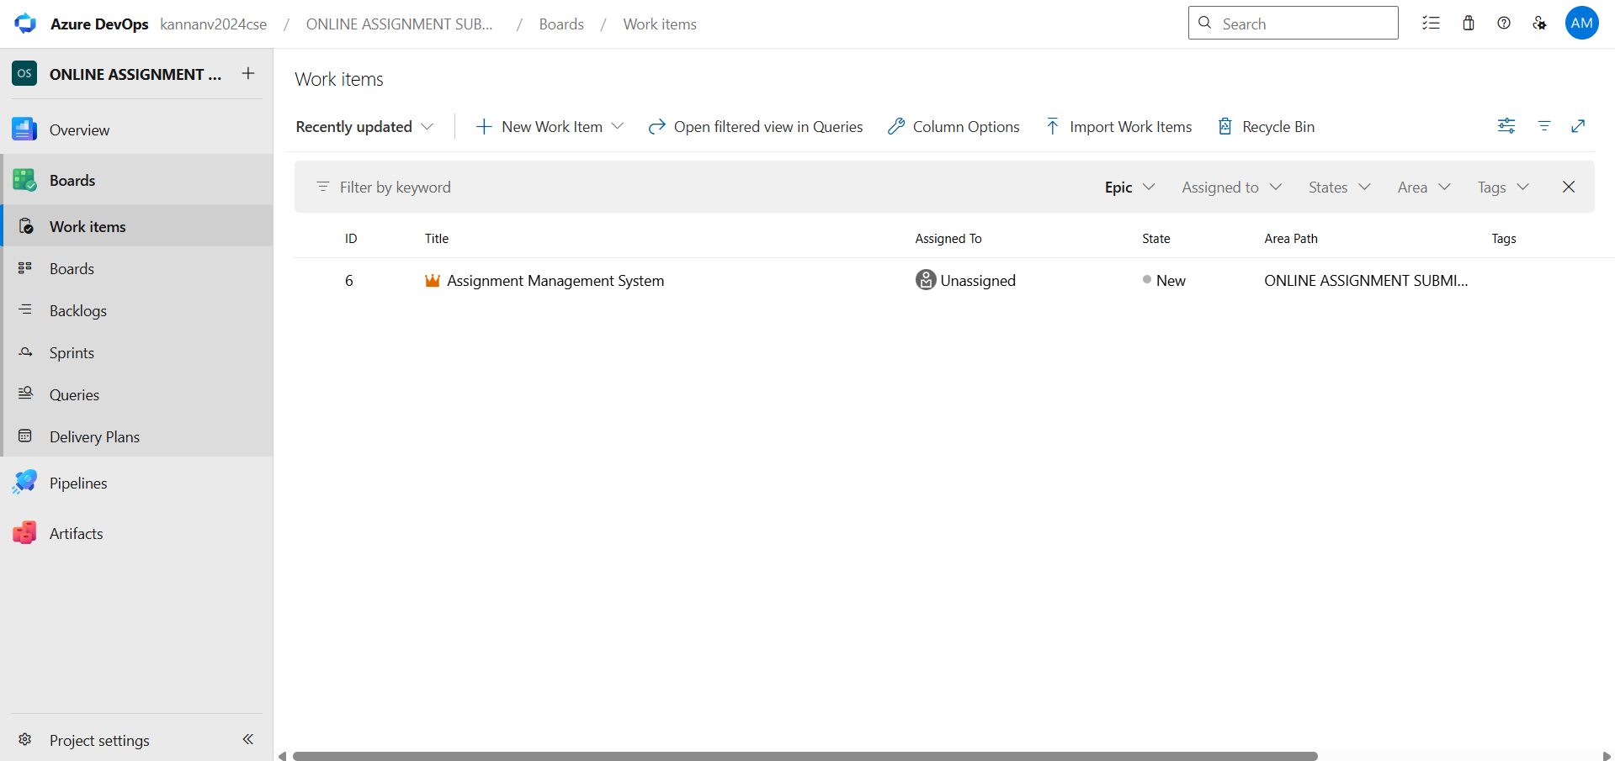

Fill in User Story Details
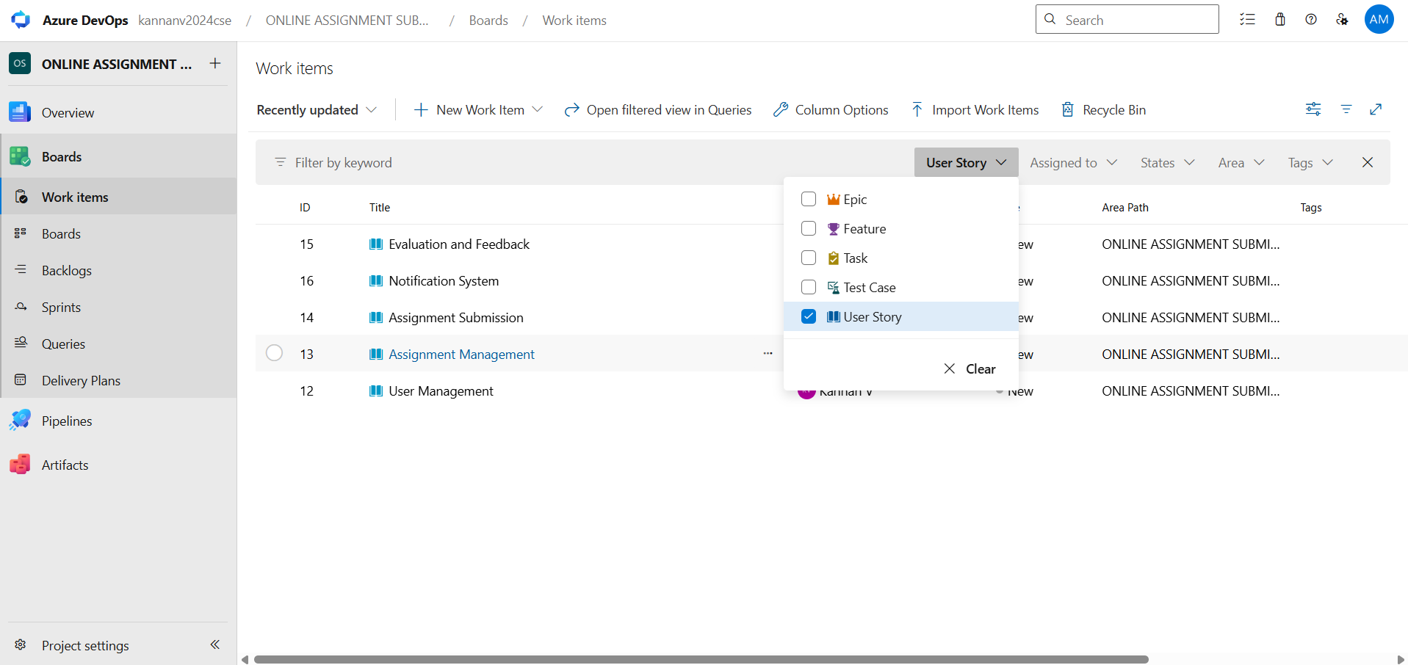

Result:
Thus, the creation of epics, features, user story and task has been created successfully.

SPRINT PLANNING

Aim:
pppppppp
Create Epic, Features, User Stories, Task
To assign user story to specific sprint for Online subscription management System Project.

Sprint Planning
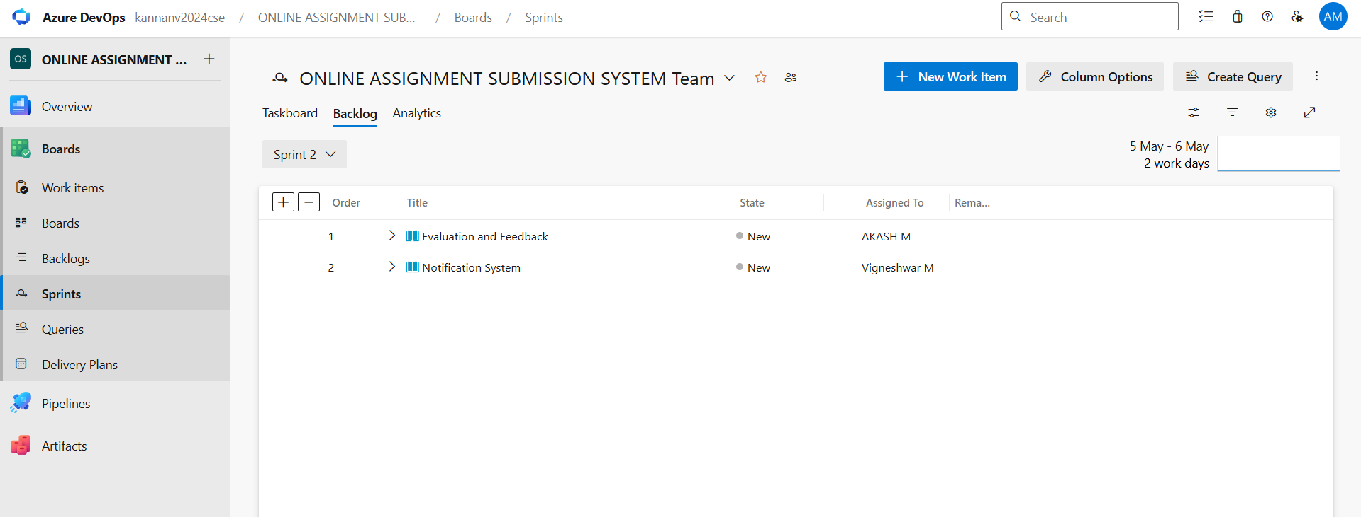

Sprint Planning – Description

Sprint Planning is a key meeting in Agile development where the team decides what work will be completed in the upcoming sprint. During this session, the product owner presents the prioritized tasks (user stories), and the team discusses, estimates, and selects the items they can realistically finish within the sprint duration.
It helps the team set clear goals, plan their work, and ensure everyone understands their responsibilities. Overall, Sprint Planning ensures that the sprint starts with a clear direction and achievable object.

Result:
The Sprints are created for Online Subscription Management System Project.

POKER ESTIMATION

Aim:
EXP NO: 5
Create Epic, Features, User Stories, Task
Create Poker Estimation for the user stories – Online subscription management System Project.

Poker Estimation
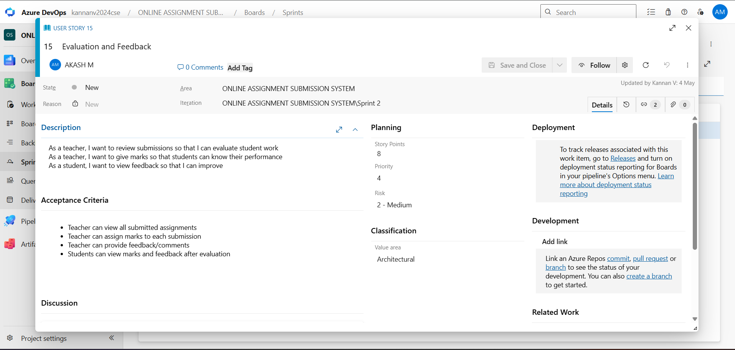

Result:
The Estimation/Story Points is created for the project using Poker Estimation.

DESIGNING CLASS, SEQUENCE AND USE CASE DIAGRAMS FOR PROJECT ARCHITECTURE

Aim:
EXP NO: 6
Create Epic, Features, User Stories, Task
To Design a Class Diagram, Sequence Diagram and Use Case Diagram for Online Job

Application System Project.

6A. Class Diagram
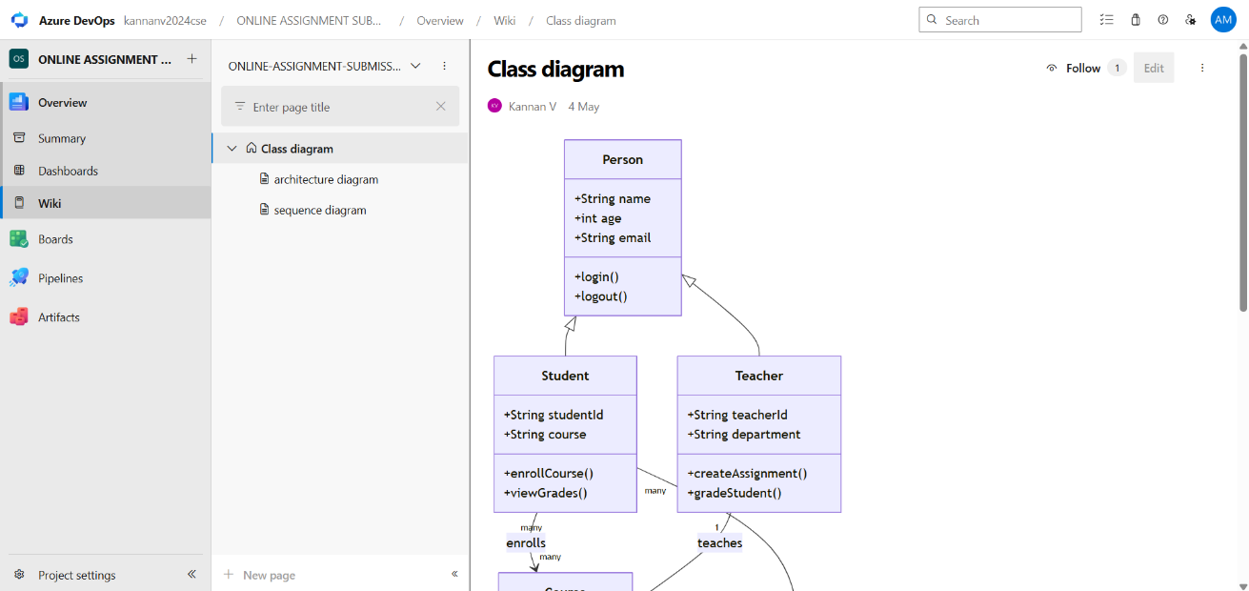

6B. Sequence Diagram
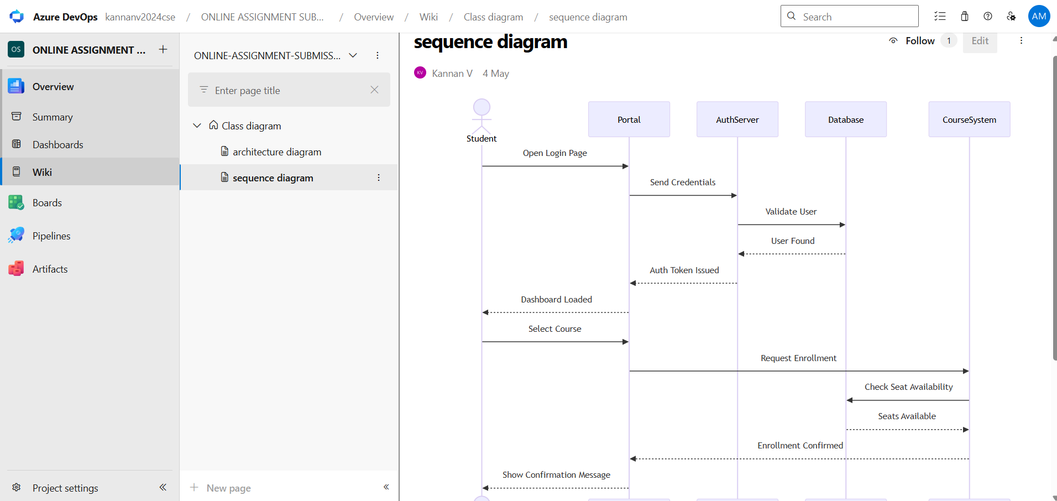

6C. Use Case Diagram
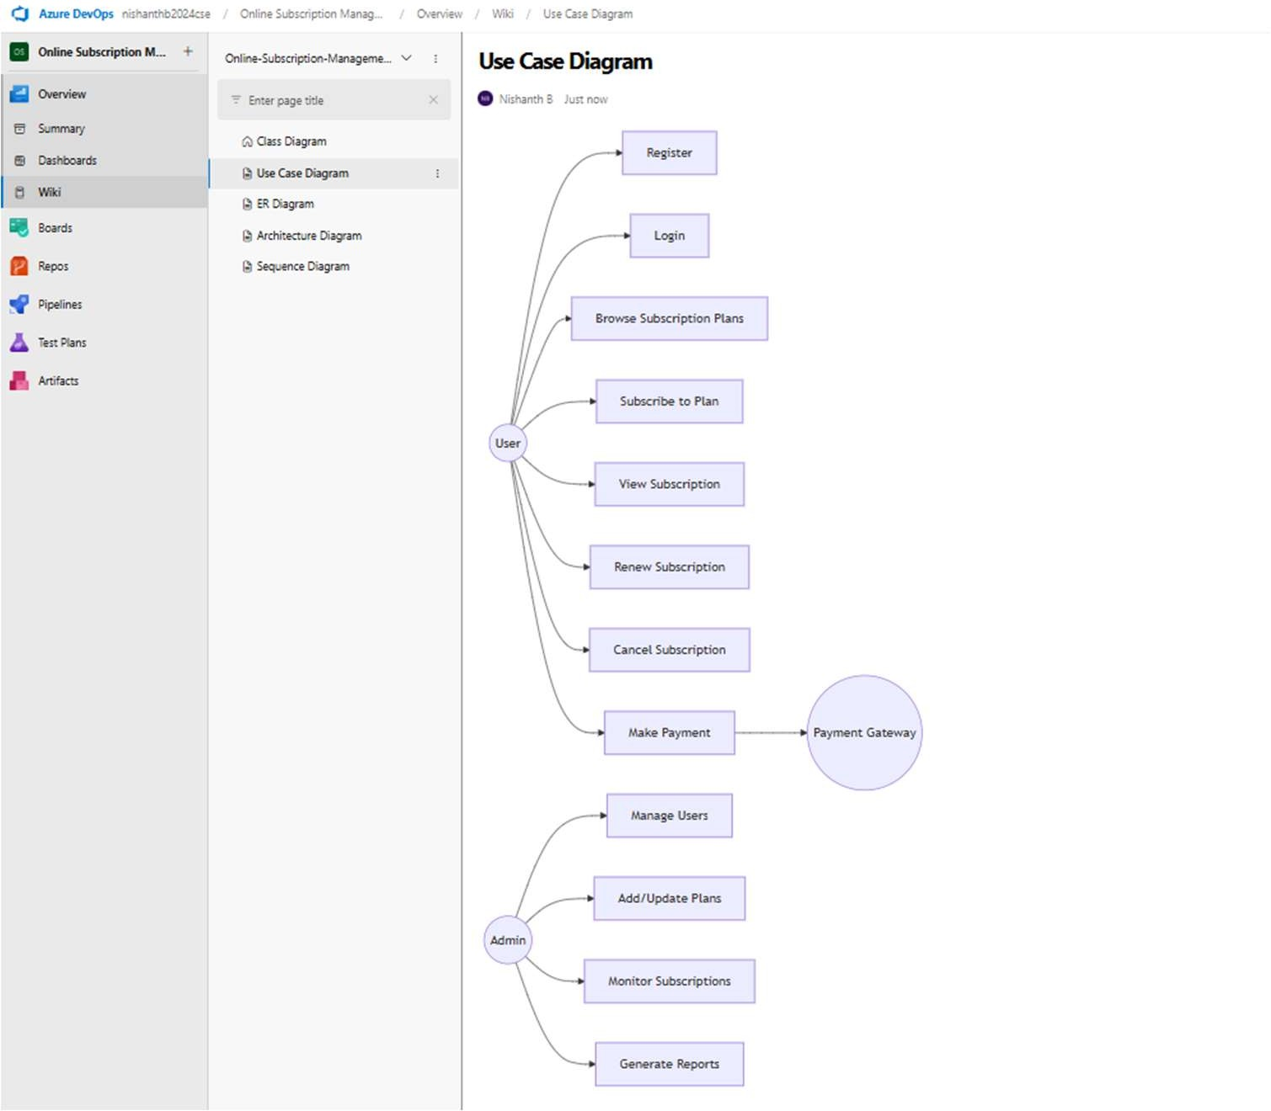

Result:

The Class Diagram and Sequence Diagram is designed Successfully for Online Subscription Management System

DESIGNING ARCHITECTURAL AND ER DIAGRAMS FOR PROJECT STRUCTURE

Aim:
EXP NO: 7
Create Epic, Features, User Stories, Task

To Design an Architectural Diagram and ER Diagram for Online Subscription Management System Project.

7A. Architectural Diagram
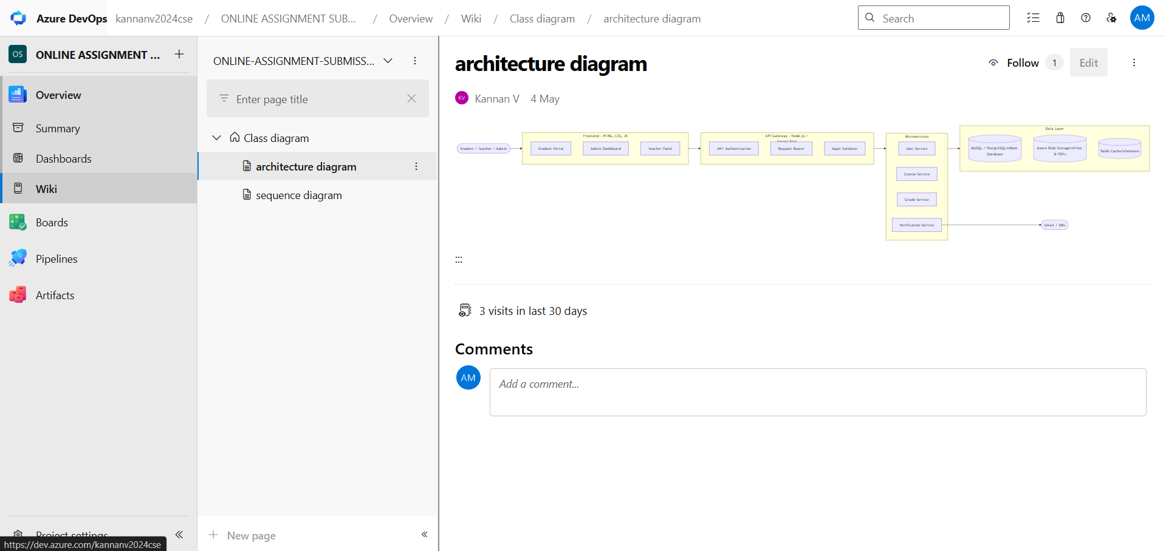

7B.ER Diagram.
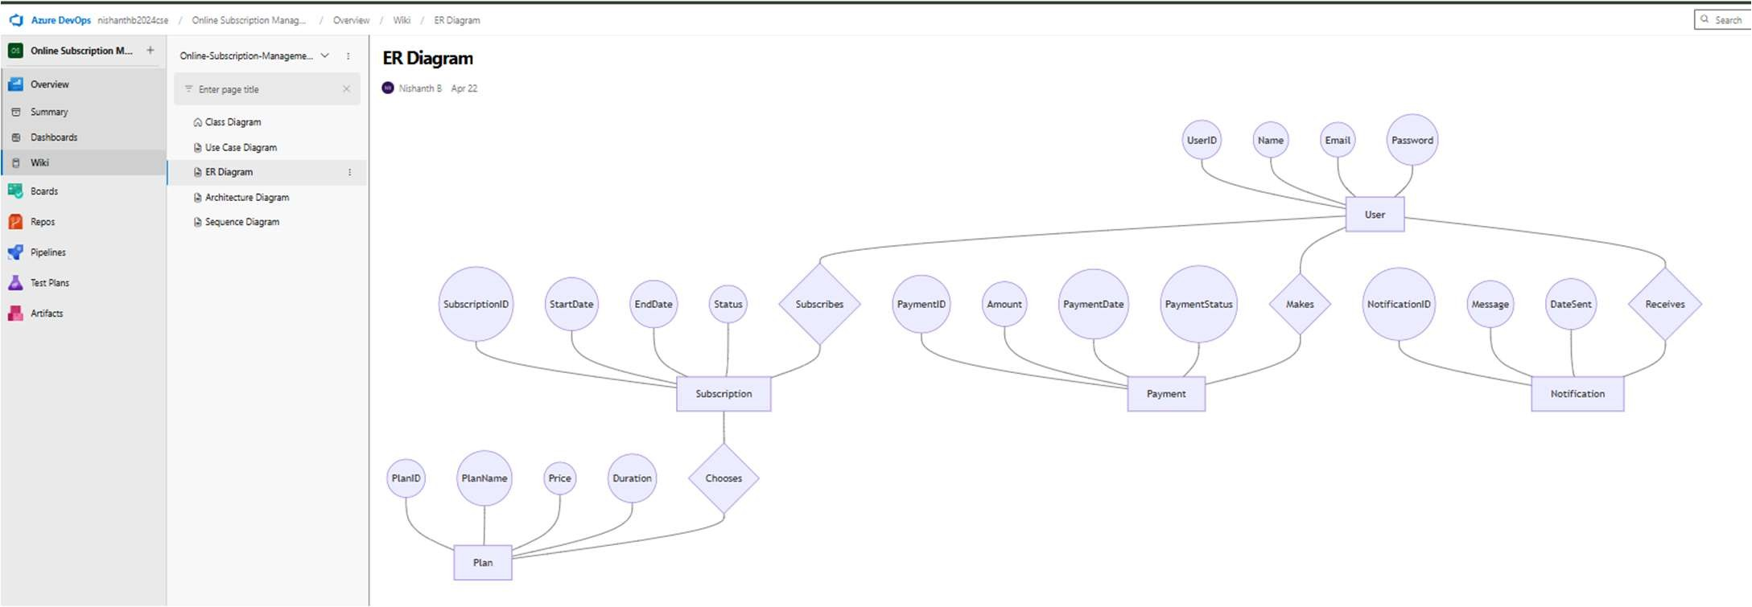

Result:

The Architecture Diagram and ER Diagram is designed Successfully for Online Subscription Management System Project.

TESTING – TEST PLANS AND TEST CASES

Aim:
EXP NO: 8
Create Epic, Features, User Stories, Task
Test Plans and Test Case and write two test cases for at least five user stories showcasing the
happy path and error scenarios in azure DevOps platform.

Test Planning and Test Case
- New test plan
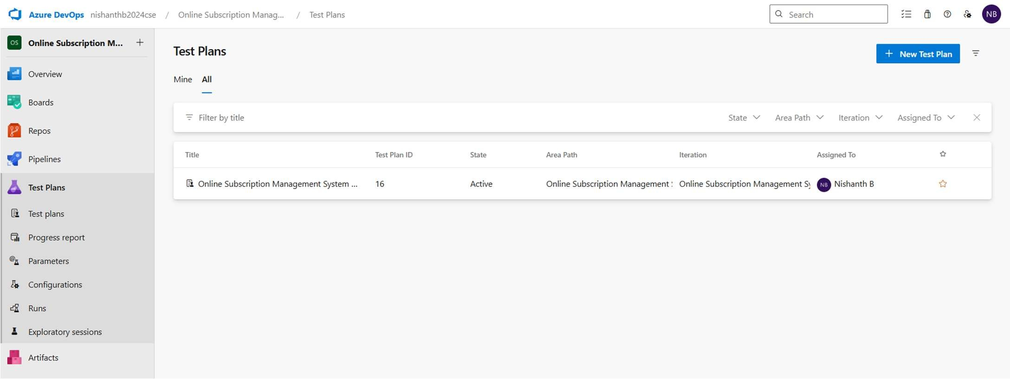

Test suite
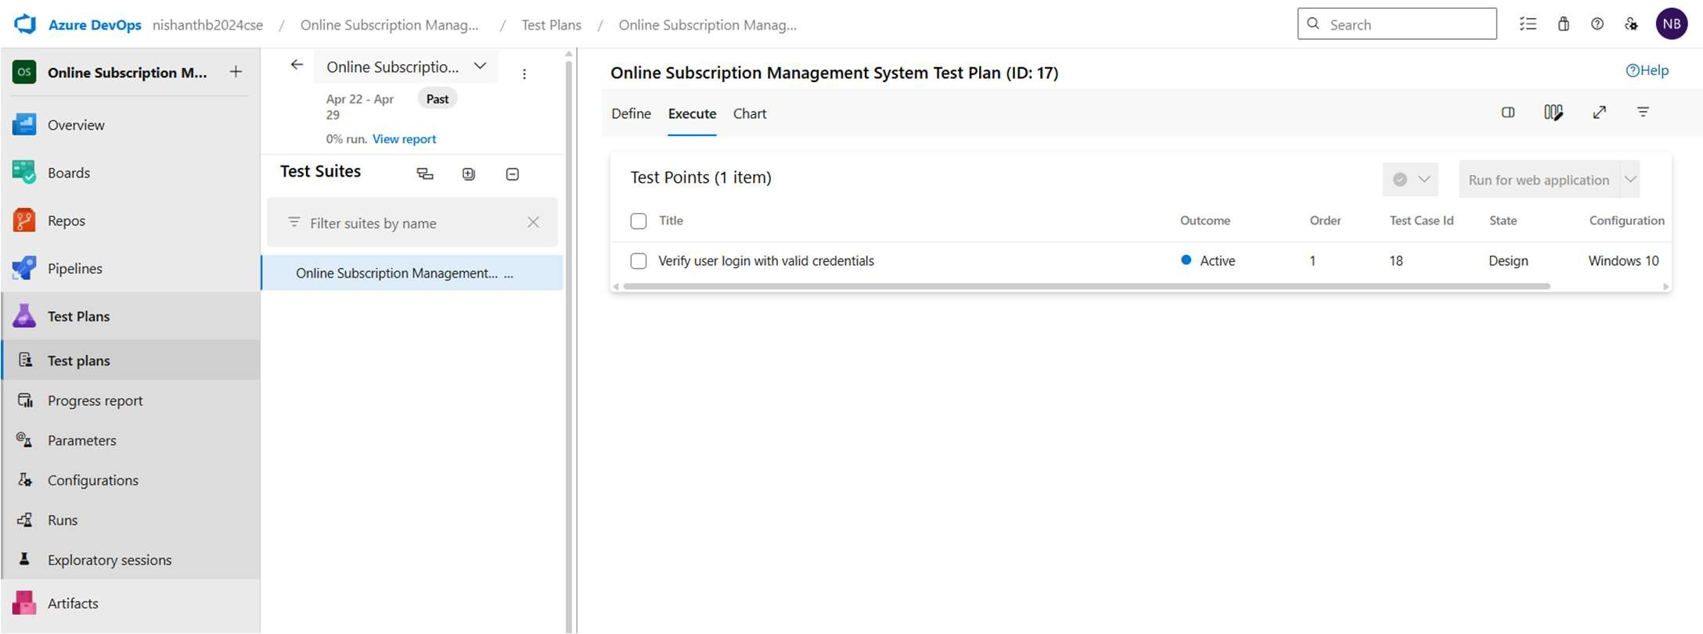

Test case

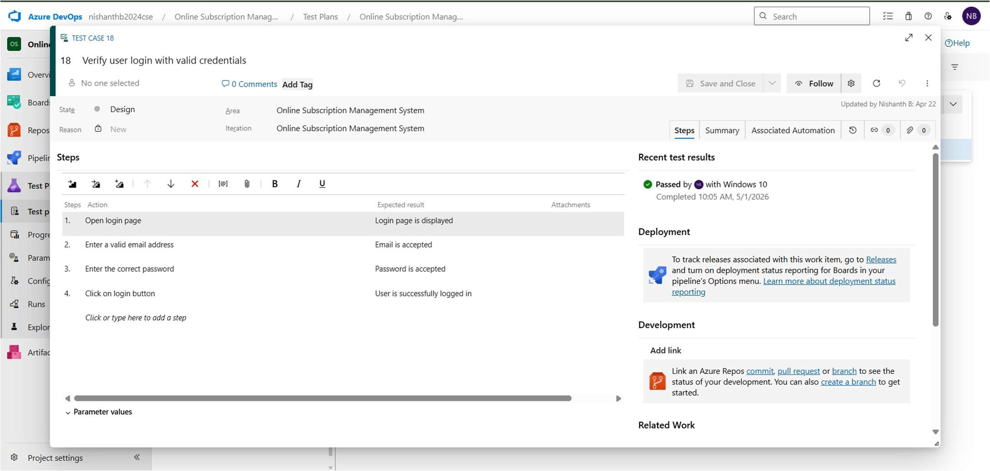

Test report summary
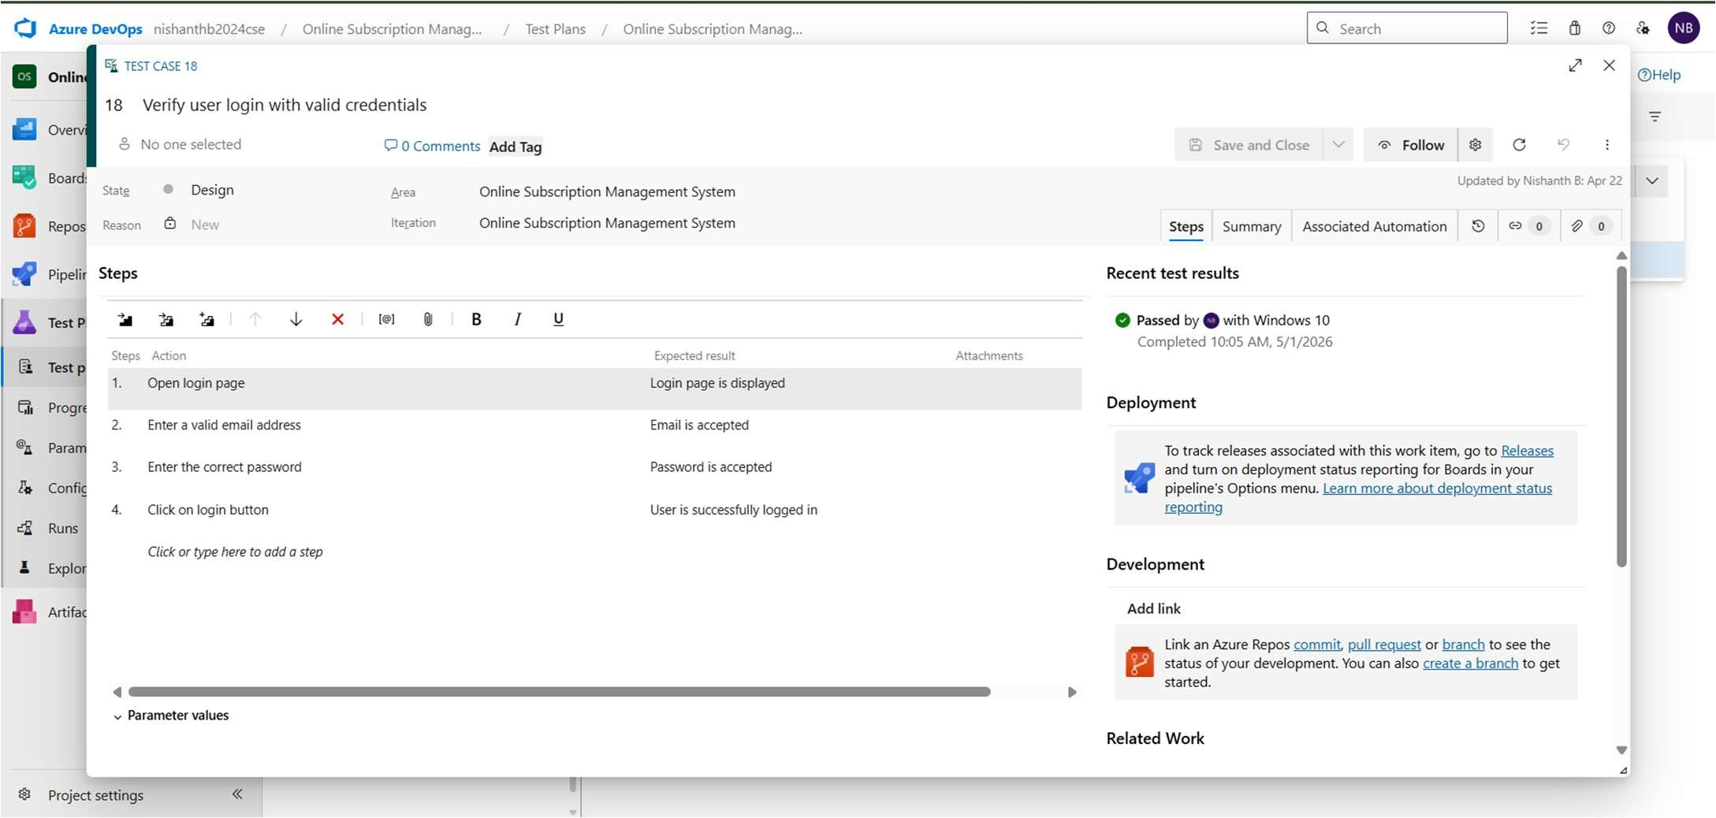

Result:
The test plans and test cases for the user stories is created in Azure DevOps with Happy Path and
Error Path
LOAD TESTING AND PIPELINES

Aim:
EXP NO: 9
Create Epic, Features, User Stories, Task
To create an Azure Load Testing resource and run a load test to evaluate the performance of a target endpoint and to create and demonstrate an Azure DevOps pipeline for automating application builds, tests, and deployment.

Load Testing
Azure Load Testing:
Azure Load Testing allows you to simulate high traffic and stress tests for your web applications and APIs to understand how they perform under load. It helps identify performance bottlenecks, scalability issues, and optimize resource usage before deployment.

Steps to Create an Azure Load Testing Resource:
Before you run your first test, you need to create the Azure Load Testing resource:
- Sign in to Azure Portal
Go to https://portal.azure.com and log in.
- Create the Resource
  - Go to Create a resource → Search for “Azure Load Testing”.
  - Select Azure Load Testing and click Create.
- Fill in the Configuration Details
  - Subscription: Choose your Azure subscription.
  - Resource Group: Create new or select an existing one.
  - Name: Provide a unique name (no special characters).
  - Location: Choose the region for hosting the resource.
- (Optional) Configure tags for categorization and billing.
- Click Review + Create, then Create.
- Once deployment is complete, click Go to resource.

Steps to Create and Run a Load Test:
Once your resource is ready:
- Go to your Azure Load Testing resource and click Add HTTP requests > Create.
- Basics Tab
  - Test Name: Provide a unique name.
  - Description: (Optional) Add test purpose.
  - Run After Creation: Keep checked.
- Load Settings
  - Test URL: Enter the target endpoint (e.g., https://yourapi.com/products).
- Click Review + Create → Create to start the test.

Load Testing
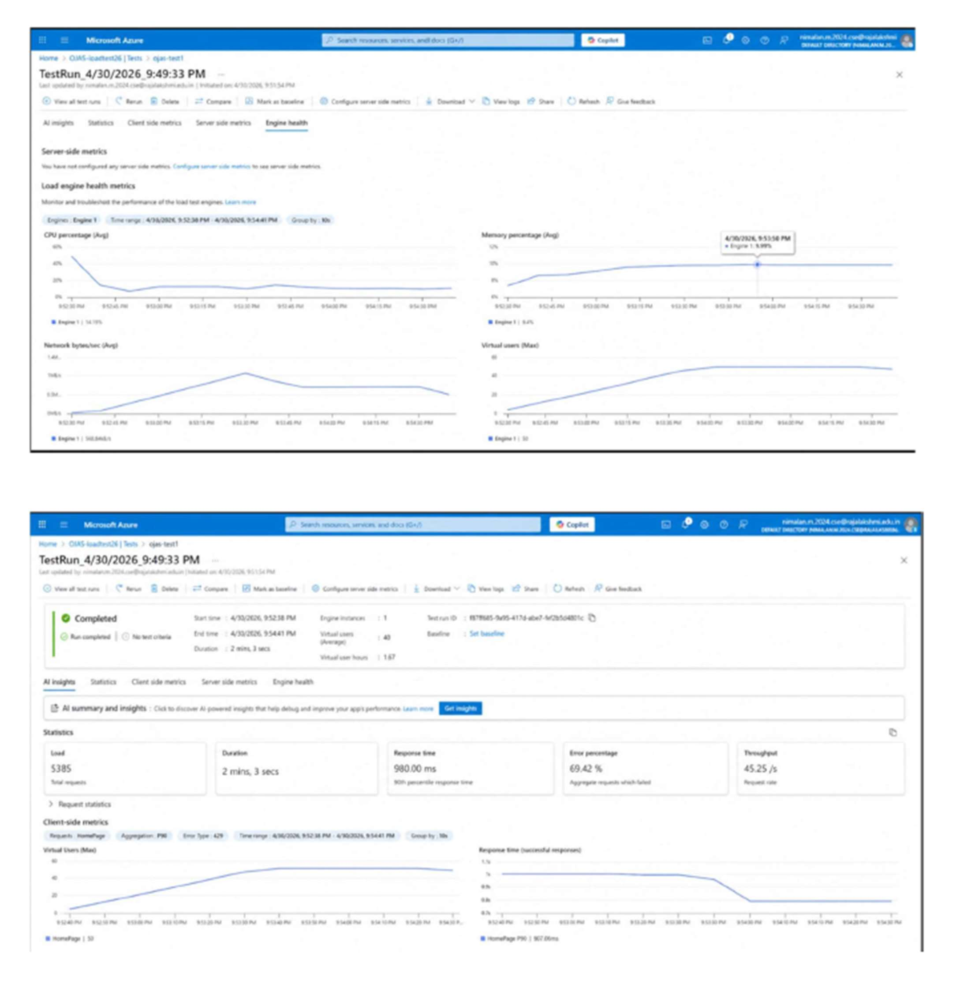

Pipelines

Description:
This experiment demonstrates how to connect a GitHub-hosted project with Azure DevOps. The pipeline automatically installs dependencies, builds the application, and runs basic scripts to verify functionality. This ensures that every commit triggers automated checks, improving reliability and enabling smooth deployment.

Steps:

Connect GitHub to Azure DevOps:
  - Create a new project in Azure DevOps
  - Create a pipeline and select GitHub as the source
  - Authorize access to your GitHub repository
- Create azure-pipelines.yml in repository root:
  - Add a new file named azure-pipelines.yml
  - Paste the configuration below

Run and Monitor Pipeline:
  - Commit code to the main branch
  - Pipeline will trigger automatically
  - Check logs in Azure DevOps for execution status

Pipeline Tasks Include:
- Setting up Node.js environment using NodeTool
- Installing frontend and backend dependencies
- Building frontend application
- Running backend script to verify execution
- Automatically triggering pipeline on every commit

Pipeline
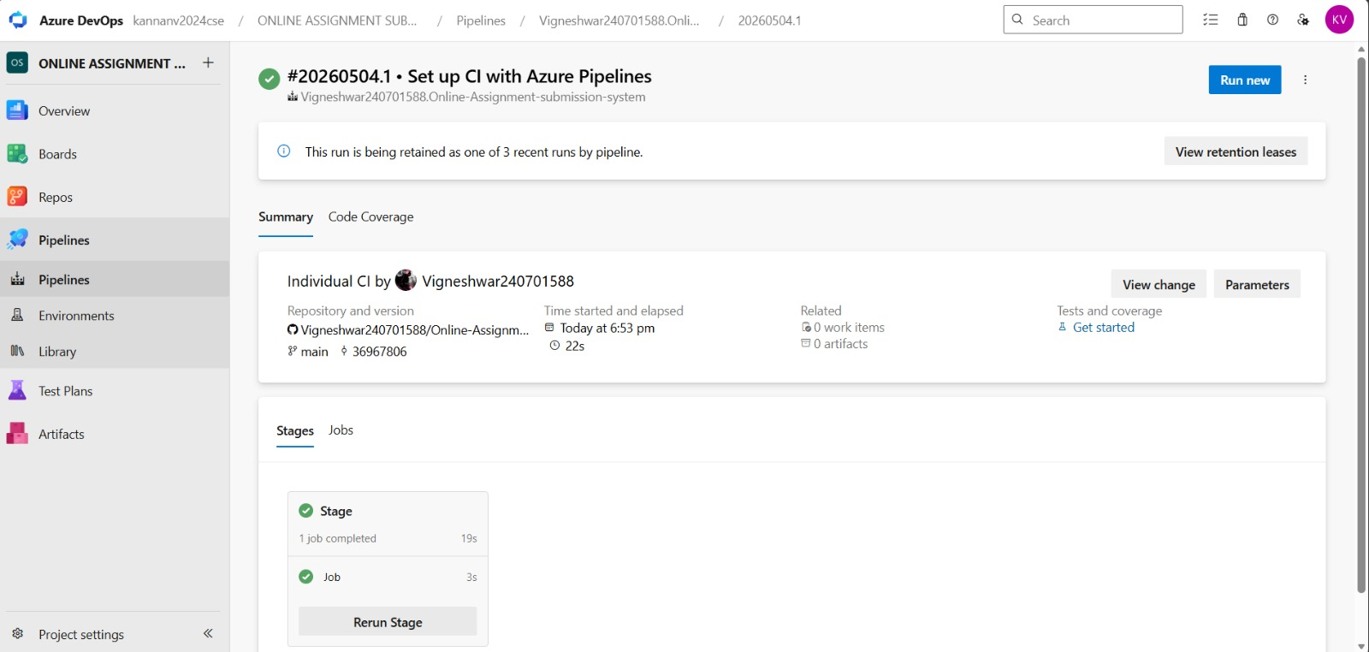

Result:
Successfully created the Azure Load Testing resource and executed a load test to assess the performance of the specified endpoint and also demonstrated pipelines in azure devops.

GITHUB: PROJECT STRUCTURE & NAMING CONVENTIONS

Aim:
EXP NO: 10
Create Epic, Features, User Stories, Task
To provide a clear and organized view of the project's folder structure and file naming conventions, helping contributors and users easily understand, navigate, and extend for Online Job Application System project.

GitHub Project Structure
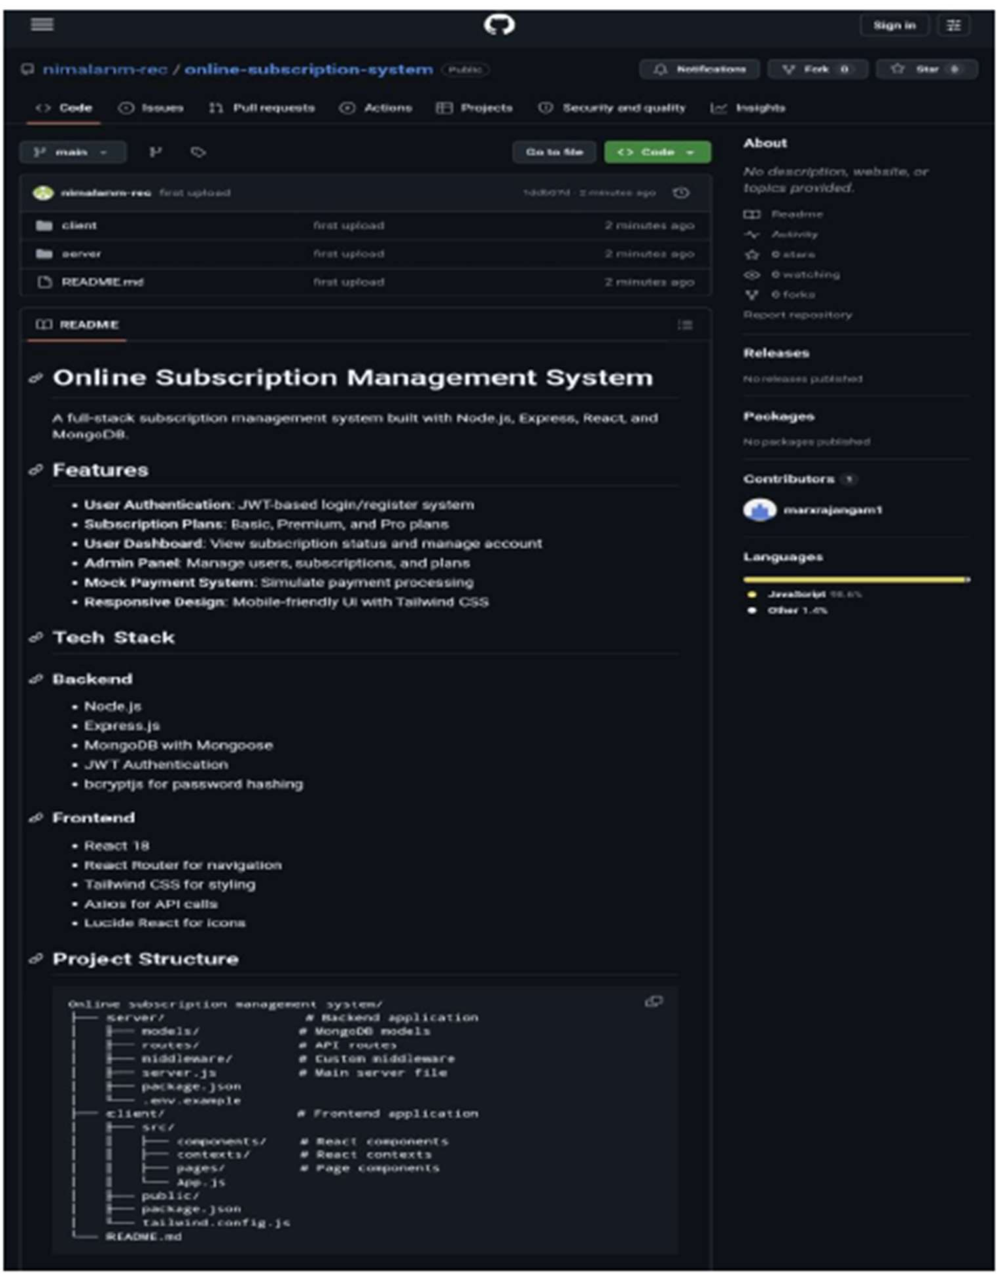

Result:
The GitHub repository clearly displays the organized project structure and consistent naming
conventions, making it easy for users and contributors to understand and navigate the codebase.

